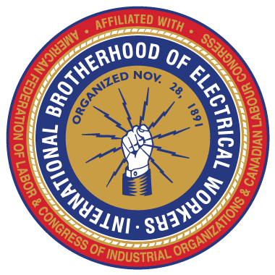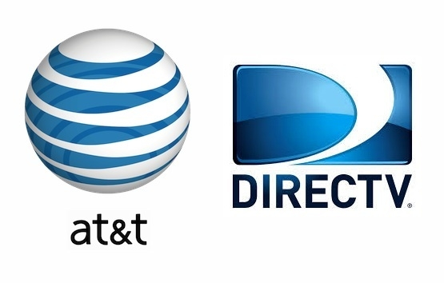

The IBEW Bargaining Team
will be on site
Tuesday July 26, 2016
8am – 8pm
to answer questions about the
Tentative Contract between AT&T and the IBEW that you will be voting on.
You will be receiving your ballot in the mail very soon.

