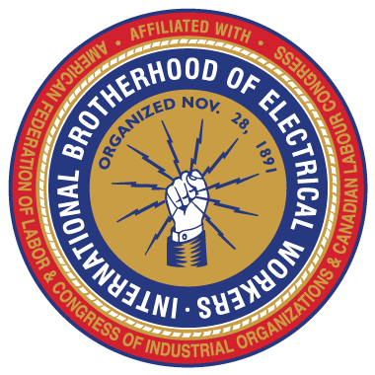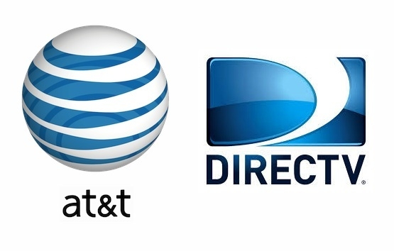
KNOW YOUR CONTRACT
Informational classes are being held soon to help you understand the new working agreement between AT&T and IBEW Local 291
Monday September 19, at 11 am & 4 pm
&
Tuesday September 20, at 11 am & 4 pm
Classes are the same so you only need to attend one session.
Representatives from the IBEW and the Call Center will be there to go through the contract and to answer questions.

All classes will be held at the IBEW Union Hall located at
225 N. 16th St. Boise Id. 83702

